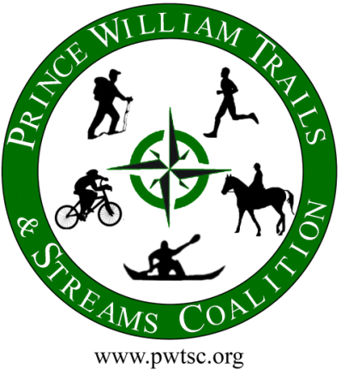
FOR IMMEDIATE RELEASE
Date: September 27, 2025
Contact: Bill McCarty wmccarty@manassaslawyers.com Veronica Tangiri (571-379-7514/ waterquality@pwswcd.org

www.pwtsc.org

News Release

Volunteers Needed to Clean Occoquan River –
The water supply for most of Eastern Prince William & Fairfax Counties

On Saturday, September 27, 2025, from 9 a.m. until 12 p.m. (rain date October 4, 2025), Prince William Trails and Streams Coalition (PWTSC), a 501(c)3 organization, is conducting its 16th annual clean-up of the upper Occoquan River, from nine different sites along 25+ miles of the Occoquan River. The cleanup ranges from Cedar Run/Broad Run, through Lake Jackson, and from the base of Lake Jackson Dam to Hooes Run (south of Lake Ridge Marina).
During the 2024 cleanup, over 80 volunteers on both water and land collected nearly 4,000 pounds of trash, putting in over 320 hours of volunteer time.

Homeowners’ associations, civic associations, and businesses are encouraged to help in this effort.

Experienced kayakers, canoeists, Jon boaters, and pontoon boaters are also requested for the on-the-water portion of this conservation effort.
Boaters are expected to put-in and take-out at the same access point. If you put in one location and take out at another, you must make transportation arrangements (no shuttle service is available).

Attached is a map showing the general water and land clean-up areas for planning purposes.

Interested participants should register at www.pwtsc.org for any new information and cancellation updates.

For Clean-up points: Contact Bill McCarty (wmccarty@manassaslawyers.com) and Veronica Tangiri at waterquality@pwswcd.org (571-379-7514).
For cleanup supplies, data sheets to report cleanup data, or to share pictures, contact: waterquality@pwswcd.org (571-379-7514)

PHOTOS BELOW
